Neighborhood development start-up project …
Draft 3-7-2026, peter.bootsma@noordenduurzaam.nl

Context and process
The social cohesion and self-reliance of the neighborhood [] need a boost, among other things with regard to the [ energy transition ] .
… takes the initiative to this end and brings together a supervisory group and a neighborhood initiative group for a start-up project.
The supervisory group is compiling this proposal and is available for guidance.
The start-up project can begin as soon as there is sufficient support from the neighborhood initiative group and a start-up budget is available.
To obtain a start-up budget, a grant application is submitted to …, the municipality, and one or more funds.

Problems and consequences
Unprocessed past . A lot has happened in the neighborhood and there are frustrations. Partly due to this, self-organization is on the back burner, and bottom-up neighborhood development is not getting underway on its own .
Lack of overview . The neighborhood has an insufficient understanding of what is going on, what is at stake, and what is possible. This hinders the pooling of resources and the search for synergy.
The system world and the lifeworld are at a distance from each other . Particularly regarding [the energy transition], there is insufficient alignment between government policy on the one hand and the needs, possibilities, and commitment of the neighborhood on the other. This hinders the development of support and willingness to invest within the neighborhood.
Chicken and egg . The self-reliance of a neighborhood presupposes both bottom-up initiatives and democracy at the neighborhood level. These two need each other, because neighborhood democracy can legitimize, support, and accelerate initiatives, and initiatives enable neighborhood democracy to claim funding from the municipality. However, this symbiosis does not arise spontaneously, and that means missed opportunities for neighborhood development.

Goals and outcomes
The goal of this start-up project is to break the impasse, with a focus on democracy, sustainability, ownership, community, a course of action, justice, direction, self-reliance, resilience, safety, and empowerment.
The project is working on the following outcomes :
- neighborhood-wide collaboration in a transition project to be chosen by the neighborhood , limited in scope but such that the entire neighborhood is involved (or can be), experiences ownership, influence, and scope for action, and that the project gives collective self-confidence.
- A preparatory step towards a new broad neighborhood council , which democratically represents and can pool all the intellectual and organizational power of the neighborhood, which chooses which new transition projects to tackle to improve the neighborhood, which initiates and monitors these projects, and which thereby takes over the role of this start-up project.
The ambition of this start-up project is to give an impetus to the development of the neighborhood … with an innovative approach in which facilitating bottom-up activities is combined with the development of a new neighborhood council. The ambition is further to draw lessons from this for the benefit of neighborhood development in general. To this end, flanking research is being conducted in collaboration with knowledge institutions, and open access knowledge sharing is being prepared.

Concept and method

Initiative group
A first step in the start-up project is bringing together an initiative group in the space between the lifeworld and the system world. The participants are influential visionaries who wish to support this start-up project and who have direct access to the networks and governing bodies that are indispensable during transitions. These are being sought in five 'task groups': science/knowledge, citizens, government, businesses, and non-profit. See Appendix 1 for details.
The objective of the initiative group is multifaceted:
- informing the group of supervisors about the neighborhood;
- reflect on the project method for the purpose of adjusting it by the supervisory group;
- selecting a topic for the first transition project;
- Inviting the boards of networks and institutions in the neighborhood for an explanation of the transition project and exploration of a new neighborhood council model.
The initiative group consists of 5 or 10 participants, equally divided among the five task groups. They participate on a voluntary basis, homework-free . The discussions of the initiative group are organized and facilitated by the facilitators' group.

Transition projects
The subject of the first transition project is determined by the initiative group and may relate to, for example, the energy transition, sustainability, inclusion, self-reliance, neighborhood regeneration, etc. The subject is chosen in such a way that the project remains limited and feasible in terms of costs and duration, while being explicitly neighborhood-wide. In other words: low-hanging fruit. The goal is to demonstrate that neighborhood-wide collaboration is possible.
The supervision costs of the start-up project and the supervision costs of the limited transition project to be developed within it are part of the budget of this start-up project. This does not apply to the implementation costs of the transition project, for example regarding the energy transition. Securing funding for this is part of the project method, in which a fair distribution of the burden across the five task groups is sought.
The transition project is designed by a project group . The participants in the project group are involved with the subject and with the neighborhood, and are motivated and sufficiently available. The initiative group may, at its own preference, proceed as a project group itself, or may assemble a project group from the five task groups and then assume the role of client itself.
The project group is guided by the supervisory team. This guidance concerns the organization of project meetings, facilitating the thinking and design process within the project group, conducting research at the request of the project group, and contributing substantively to the co-creation of the project, for example by designing interventions and collective experiences.
See Appendix 2 for project methods and possible topics.

Neighborhood Council
In the vision of this project, the new neighborhood council is a consultative body without decision-making power over the participants . However, this neighborhood council can establish a joint neighborhood-wide transition agenda and can develop and negotiate a fair distribution of tasks, burdens, and benefits in transition projects. In doing so, the neighborhood council serves both the coordination between the municipality and the neighborhood and the coordination among the neighborhood task groups themselves. In short: a round table.
Democratic legitimacy is achieved by composing the neighborhood council exclusively from democratically elected representatives of the largest networks and institutions in the neighborhood. Therefore, there is no open participation. However, the meetings of the neighborhood council are public, and their history is available to view.
Establishing this neighborhood council is complex and challenging , also given the history of the neighborhood . Therefore, a step-by-step approach is being followed, involving close consultation with knowledge groups, citizen initiatives, the municipality, business networks, and non-profit networks in the neighborhood. This allows room for exploration, dialogue, iteration, and adjustment. The neighborhood is carefully consulted and kept informed through the neighborhood council participants and local media, and can once again continuously contribute and make choices through the participants.
An important intermediate step is the establishment of a provisional neighborhood council, which, on behalf of the boards of the neighborhood networks and institutions, handles the organization and initial staffing of the new neighborhood council. In practical terms, this means drafting and adopting a neighborhood council manifesto and internal regulations, inviting the largest democratic networks and institutions in the neighborhood to nominate representatives, and organizing a handover.
The provisional neighborhood council is established following personal consultations between the members of the initiative group and the boards/networks within their respective task forces, and after a joint exploration in one or several sessions. As soon as the provisional or permanent neighborhood council exists, the initiative group may, at its own discretion, dissolve itself or continue as an advisory body or project group of the neighborhood council. For members of the initiative group who meet the requirements, the transition to the (provisional) neighborhood council may be of interest.

Research and guidance
At the request of the initiative group, the project group, and the (provisional) neighborhood council, the supervisory group conducts research by means of interviews and desk research. The research concerns, among other things:
- stakeholder analysis;
- vision development using story mapping in (among others) the initiative group;
- maintaining the timeline of the start-up project;
- inventorying initiatives using gebiedonline ;
- collecting narratives in the neighborhood;
- compiling a glossary for the neighborhood;
- inventorying actors and actor networks in five task groups;
- research at the request of the project group (see below);
- evaluation research;
- …
The supervisory group produces the following documents, among others:
- This project plan (to be developed in versions)
- A step-by-step plan for district-wide project plans (detailing of Appendix 2)
- An up-to-date overview of actors per task group in the neighborhood
- A current overview of topics suitable for neighborhood-wide projects
- A current overview of the support services offered by …
- A draft manifesto and draft regulations for the neighborhood council
- …

Actors and roles
The facilitator group is responsible for process design and change management guidance. The facilitator group currently consists of:
- …
- …
- …
- …
- …
The task groups are five segments of the neighborhood that can jointly divide tasks in transition projects: science/knowledge, citizens, government, businesses, and non-profit (see also Appendix 1).
The initiative group exists to a) select the first (simple) transition project, design a plan for this with support from the facilitators' group, and set it in motion, and b) invite the directors of the task force networks and institutions to explore the possibility of a new neighborhood council. Prior to and during this project, the initiative group will be further supplemented by influential visionaries, and currently consists of:
- Science/knowledge
  - …
  - …
- Burgers
  - …
  - …
- Government
  - …
  - …
- Companies
  - …
  - …
- Non-profit (education, healthcare, sports, culture, philosophy of life, housing associations, etc.)
  - …
  - …
The initiative group has no chairperson. Technical moderation is provided by the supervisory group.
The provisional neighborhood council consists of representatives of democratic networks and institutions in the five task groups and exists to prepare the new neighborhood council on behalf of the entire neighborhood.
The new neighborhood council consists of representatives of democratic networks and institutions in the five task groups and exists to establish a change agenda on behalf of the entire neighborhood, to initiate and monitor transition projects in the neighborhood, and to support and accelerate initiatives from and for the neighborhood.
Project groups exist to design neighborhood-wide transition projects, gather conditional intentions in the neighborhood ( we participate if everyone participates ), organize the kick-off, and report progress to the neighborhood council.

Innovative character
The proposed approach is innovative in the sense that it a) is based on self-reliance and the division of transitional tasks , and b) aims for synergy between the level of decentralized bottom-up initiatives and the level of central democratic coordination . This differs from the conventional approach to bottom-up initiatives, which often involve some but not all sectors, thereby leaving opportunities for synergy and scaling up untapped. This also differs from conventional forms of neighborhood democracy, which are often weakly developed and lack a democratic platform where the full organizational capacity of the neighborhood converges on an equal footing.
Is this necessary? By way of a thought experiment, below are four alternative approaches in which one element from the proposed approach is omitted.
- Focusing on the energy transition without committing to a new neighborhood council will not create a platform where the entire neighborhood is democratically represented and where transition tasks can be distributed. For every transition, a new coalition of neighborhood actors would then have to be formed and legitimized.
- Focus on a new neighborhood council without committing to a concrete project. This can become too abstract, too bureaucratic, and too large for the task forces and their representatives.
- Do not impose structure, only facilitate the process. This can contribute to successful bottom-up activities, but the new neighborhood council could then become an arena for vested interests and power struggles. That hinders neighborhood-wide cooperation and the scaling up of initiatives.
- No process facilitation, only proposing structures. Without practical experience and insight, it is unlikely that an equitable division of tasks and democratic coordination of transitions will emerge spontaneously.
In addition to new starting points, the working method also features innovative elements. Examples:
- The application of story mapping in a neighborhood-wide and therefore political context.
- A task group model as the basis for equal collaboration.
- A voting system for setting the agenda between task groups.
- A brainstorming canvas for the design of neighborhood-wide transition projects.
- …
Conclusion: the complexity of the transitions facing … and many other neighborhoods justifies an experiment with an approach that combines decentralized initiative with central coordination and provides not only process guidance but also structure for this. This start-up project thus goes further than many pilot projects and possesses the DNA for continuity within the neighborhood and for broader application in other neighborhoods. At the same time, the approach is new and not yet fully developed, which makes flanking research important.

Step-by-step plan and phasing

Initiation phase ( … )
- … invites change management experts to form a facilitator group.
- The supervisory group is designing this start-up project.
- With this plan, funding is sought for guidance in the subsequent phases.
- Go/no-go decision by the supervisory group and … .

Preparation phase ( … )
- Division of tasks within the supervisory group: who will supervise which task group?
- Finding influential visionaries : people with a vision who want to actively contribute to this project as members of an initiative group and who have access to administrators in their own task force.
- Interviews with (members of) the initiative group to map the history, narratives, transition topics, and network of the neighborhood.
- A simulation workshop with the initiative group to demonstrate the project method and reflect on it, and to select a topic for a transition project.
- Adjusting the project method based on the reflection.
- Go/no-go decision by the initiative group.

Start-up phase

First transition project
- Formation of a project group by the initiative group.
- Designing and initiating the first transition project by the project group, see Appendix 2.

Administrative exploration
- Adoption of a draft manifesto and draft regulations for the neighborhood council by the initiative group, based on sample material.
- Personally inviting boards to the task groups for an exploration in a few sessions, by the members of the initiative group; sending drafts; preliminary discussions.
- Presentation by the initiative group: values, problems, vision, goals, initiative group, approach, transition project, neighborhood council manifesto, guidance, funding, risk management, evaluation, etc.
- A simulation workshop to demonstrate the project method and to reflect on it, and to select trial topics for future transition projects.
- Debate , inventorying proposed adjustments, gauging support for them.
- To formulate of a proposal for a provisional neighborhood council , with the draft manifesto and draft regulations as attachments.
- Second/final session: go/no-go decision by the administrators to submit the proposal for a provisional neighborhood council to their boards.

Continuity phase
- Approval of the proposal for a provisional neighborhood council by the boards and appointment of representatives.
- Installation of the provisional neighborhood council.
- Further development, negotiation, and adoption of the manifesto and regulations, in consultation with the boards.
- Installation of the neighborhood council.
- Taking over the monitoring of the initiative group's first transition project and deciding on the status of the initiative group ( completion, advisory role , etc.).
- Starting the cycle
  - Establishing a change agenda for future projects.
  - Initiating transition projects (via project groups)
  - Monitoring trends and transition projects

Costs and funding ( to be worked out in consultation )
Cost estimate
- Supervisors' group: hours and expenses
- Meeting
- Research
- Communication
Revenue budget
- …
- Government free project space
- Subsidy schemes
- Funds

Risks and measures
- Insufficient support in the neighborhood. Measure:
  - Phasing the plan and incorporating go/no-go decisions per phase.
  - Starting from the history, culture, and circumstances of the neighborhood.
  - Preliminary discussions with stakeholders.
  - Room for adjusting the approach and for iterations.
- Insufficient resources for support. Measure:
  - Requests to multiple governments and funds.
  - Upfront investment by supervisors.
- The neighborhood council model is considered too burdensome. Measure:
  - Drawing attention to the democratic deficit at the neighborhood level.
  - Drawing attention to urgencies and the necessity of joining forces.
  - Let the model be experienced through simulation.
  - Phased approach via a provisional neighborhood council.
- One or several task groups are unwilling or unable to participate. Measure:
  - Research into interests and entry conditions.
  - Additional discussion by involved initiative group members.
  - Joint appeal from the participating task forces.
- A task force has no democratic representation. Measure:
  - Explicitly keep a spot open.
  - Opinion research within the task group so that their position is known.
  - As the first project, facilitate the self-organization of the task force.

Evaluation and follow-up ( to be determined )

Appendix 1: task-democratic neighborhood council
This appendix describes what a task-democratic neighborhood council looks like and how it functions.
The goal of a task-democratic neighborhood council is to pool the entire organizational capacity of the neighborhood to coordinate neighborhood-wide transition projects. In doing so, it is not about advocacy, but about the division of tasks.
Participation is not in a personal capacity but exclusively as a representative of a task force, with mandate and consultation, so that agreements can be made and the neighborhood can be mobilized. A task-democratic neighborhood council consists of five task forces:
- Science , represented by chairpersons of knowledgeable neighborhood working groups (in contact with scientists) for, for example, energy transition, biodiversity, heritage, spatial planning, culture, inclusivity, poverty reduction, social cohesion, etc. The task of these groups is to hold up a mirror to the neighborhood: what happens if we do nothing, and what options do we have?
- Citizens , represented by tenants' associations/residents' councils of housing corporations, neighborhood associations of Owners' Associations , and neighborhood or street committees. The task of citizens/residents during transitions is to help each other with necessary changes, and to raise the children with that attitude and value.
- Government , represented by the district alderman, or on his behalf by the area manager. An important transition task of the government is to ensure fairness, so that a comparable effort is required of everyone and a level playing field is created for entrepreneurs.
- Businesses , represented by the chairpersons of the neighborhood business association(s). The task of the entrepreneurs in the neighborhood is to invest in renewing their range of products and services.
- Non-profit , presented by representatives from education, healthcare, sports, culture, philosophy of life, housing corporations, and other non-profit organizations. The task of non-profits, or social organizations, is to prepare the neighborhood for and equip it for change.
The division into these five groups in this model has been chosen such that the task groups have unique and non-transferable tasks, and that they are interdependent. This makes the position of the participants comparable to that of collective labor agreement negotiators. A negotiating agreement must first be reached, and this must subsequently be explainable to the constituency.
The five task groups are independent in their contributions to neighborhood-wide projects and have no decision-making power over one another. The neighborhood council limits itself to coordination, synchronization, and synergy and imposes no rules or requirements on the participants. Therefore, there is no central control, but rather a joint exploration of how to strengthen one another. Task groups and the organizations within them participate because they want to, because they need each other, and because together they achieve more.
It is important that neighborhood-wide projects result in a fair distribution of burdens and benefits within the neighborhood, and that participants can explain this to their constituents. In this regard, the strongest shoulders bear the heaviest burdens, and the most disadvantaged groups must be able to count on compensation. In principle, this compensation is provided by all other groups according to their ability to pay. For this reason, too, it is important that the entire neighborhood is represented.
The comprehensive task force model enables participants to call upon their constituencies partly on behalf of the rest of the neighborhood . This shifts their position from lobbyist for specific interests to partner in collective transition leadership .
The five task groups are equal in the sense that none of the five can be dispensed with in neighborhood-wide transition projects. The five task groups are therefore given equal speaking time and equal voting rights in the neighborhood council . Consequently, the liberal-democratic principle of ' one man , one vote ' does not apply to neighborhood-wide projects , but rather the task-democratic principle of ' one task group , one vote '. After all, in the case of necessary changes where the neighborhood cannot afford division—for example, collective investment in the energy transition—it is more practical to divide the neighborhood into groups that can do specific things , rather than into groups that have different opinions . Equalizing task groups and excluding decision-making power prevents a single task group from being dominant, while simultaneously enabling coalitions that can persuade hesitant task groups.
The alignment of task groups must be accepted by the participants in advance. Therefore, the working method of a task-democratic neighborhood council is developed at an early stage in order to answer questions regarding it. This takes shape in a manifesto concerning the foundation of the neighborhood council, and regulations for matters such as admission, working methods, and decision-making. Templates for this are available.
The task-democratic structure of a neighborhood council is in principle also workable for the municipality , because it respects the legitimacy, independence, and scope of action of the government. The government can present its policy within the neighborhood council and seek support from the other four task groups. This is not merely for the sake of participation in and support for government policy, but precisely to be able to negotiate alignment between government policy and the voluntary action of the other four task groups. A task-democratic neighborhood council is a consultation platform comparable to the SER at the national level, and not a participation instrument or consultative body.
The chairperson of the neighborhood council is elected by all participants, whereby the task groups again have equal voting rights (i.e., regardless of the number of participants per task group) and the task groups nominate multiple candidates on a rotating basis.
This neighborhood council requires regulations outlining this structure, representation, internal relations within task groups, transparency, decision-making, the chairmanship, and other matters. A draft version of these regulations is required in advance to answer the questions raised by this new working method. The regulations must be adopted by the neighborhood council itself, for which purpose a provisional neighborhood council could first be established (just as participation councils in education were established in the past after the regulations were adopted in provisional participation councils).

Appendix 2: task-democratic neighborhood projects
This appendix describes what task-democratic neighborhood projects look like and how they can be established step by step.
A task-democratic neighborhood project is a neighborhood-wide collective effort for the sustainable development of the neighborhood in economic, ecological, and/or social terms. The project is initiated by a task-democratic neighborhood council following decision-making in which the entire neighborhood has a say. The neighborhood council acts as the client and fulfills this role itself or has established a broad steering group for this purpose. The project has its own revenue budget, which is established during the project design phase and arises from contributions based on the financial capacity of the neighborhood task groups and possibly from support from outside the neighborhood. The project group is composed of the five task groups. Democratic representation is not a requirement here (because the legitimacy of the project has already been established within the neighborhood council). Connection with and knowledge of one's own task group, however, is crucial for the project group members . The project group is the place for the individual ' usual suspects'. The neighborhood council grants them status and a mandate (and can also revoke this).
A project group starts from the priority set by the neighborhood council and develops a neighborhood-wide project. Steps in this process:
- Identifying values that are central to the project or are at stake.
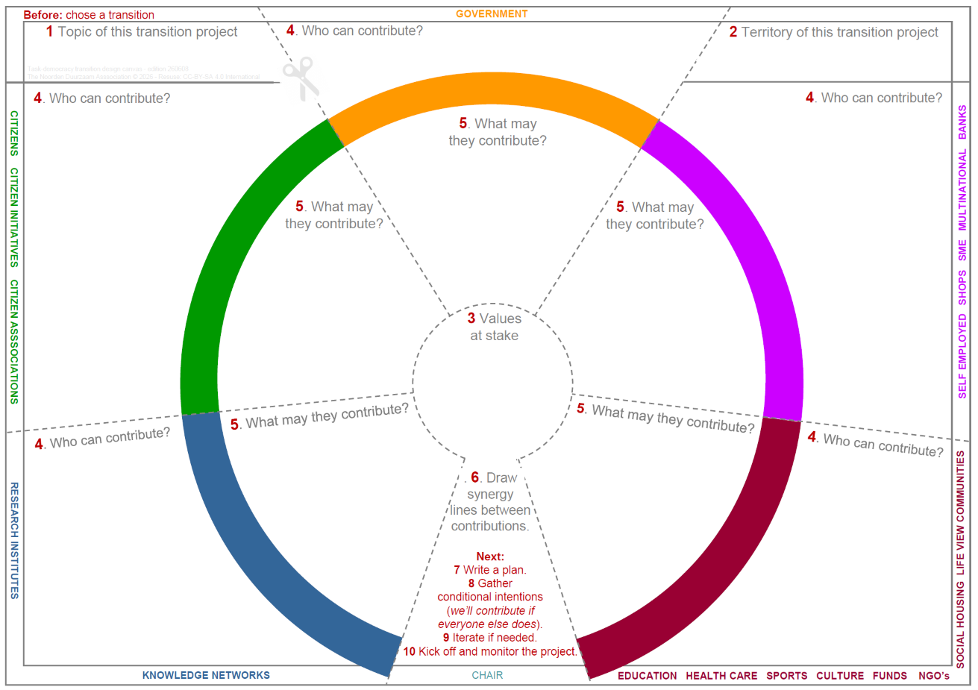
- For each task group, brainstorm which stakeholders in the constituency can contribute to the project and what their contributions might be. The depicted canvas can be used for this purpose, if necessary.
- Mapping the synergy between all contributions.
- Elaborating all of this into a collective letter of intent and a project plan.
- Visiting all actors and asking if they actually want to make the envisioned contribution if everyone does so .
- Possible iterations to incorporate new insights.
- Subject to sufficient conditional intentions (we participate if everyone participates), organize a public kick-off: signing session, press conference, drinks, etc.
- Monitor and adjust from the project group and keep the neighborhood council informed.

